Stochastic Processes and Calculus An Elementary Introduction with Applications

Uwe Hassler

Springer 2016

**Teaching Material**

The following figures are from the above book. They are provided to help instructors and students and may be used for teaching purposes as long as a reference to the book is given in class.

D:\Hassler\Eigene Dateien\scfe\ws1516\slides\ARMA\ma1.eps

**Figure 3.1** Simulated MA(1) Processes with σ² = 1 and μ = 0

D:\Hassler\Eigene Dateien\scfe\ws1516\slides\ARMA\ar1_tomi.eps

**Figure 3.2** Simulated AR(1) Processes with σ² = 1 and μ = 0

*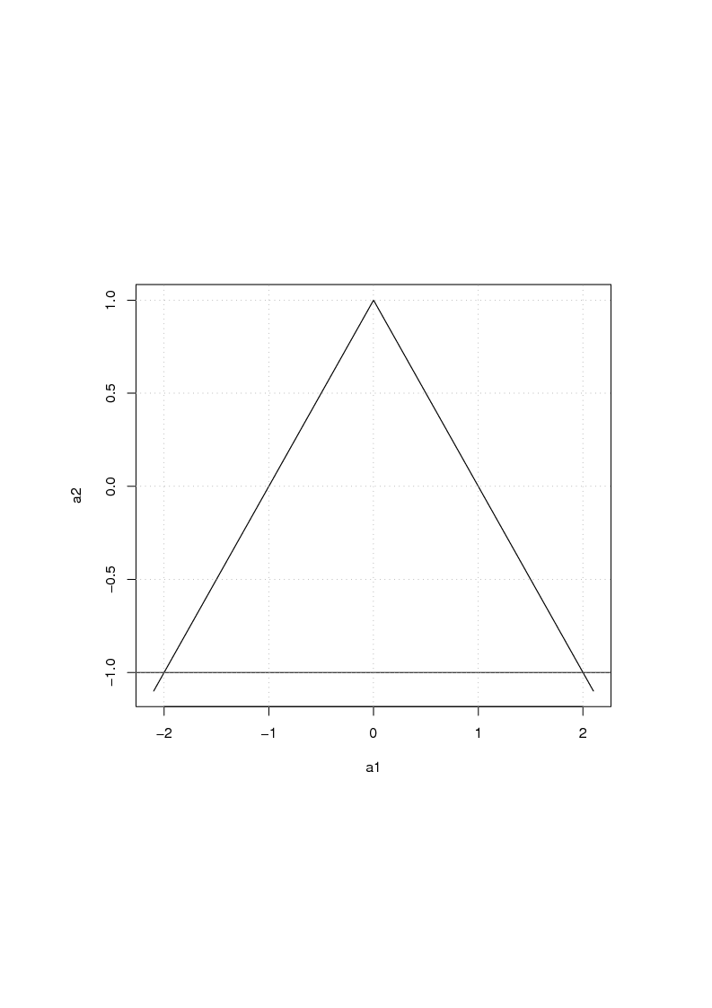*

**Figure 3.3** Stationarity Triangle for AR(2) Processes

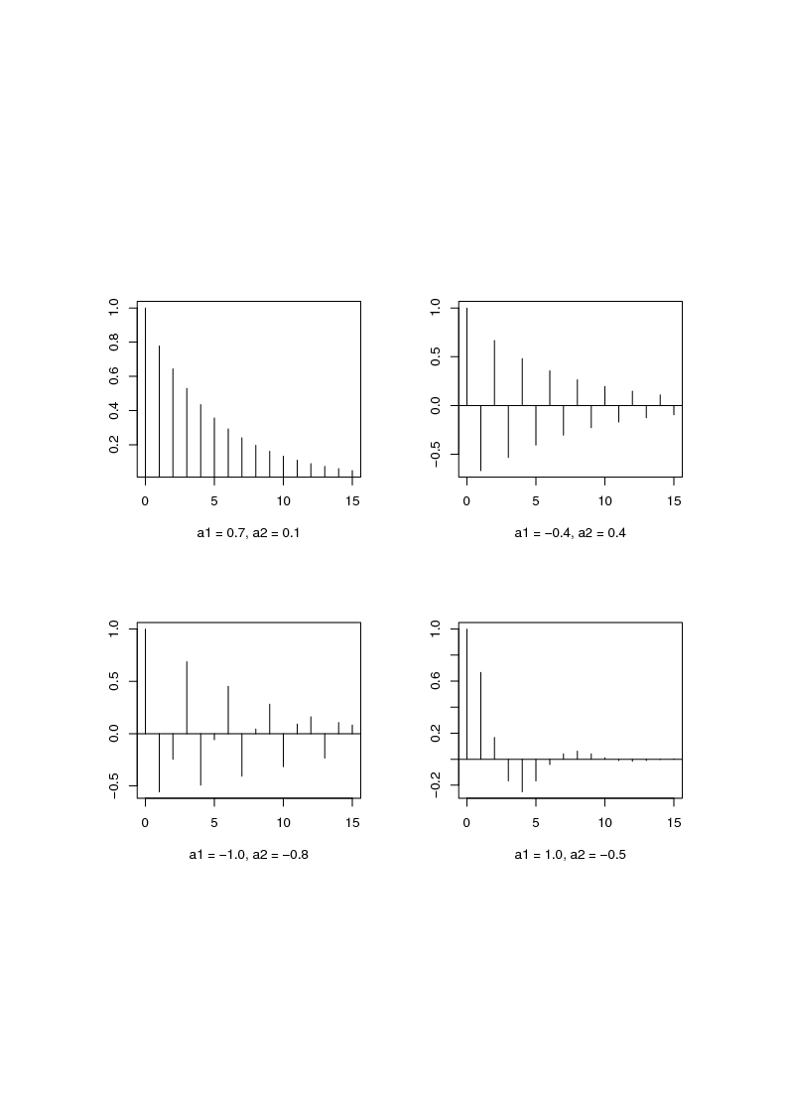

**Figure 3.4** Autocorrelograms for AR(2) Processes

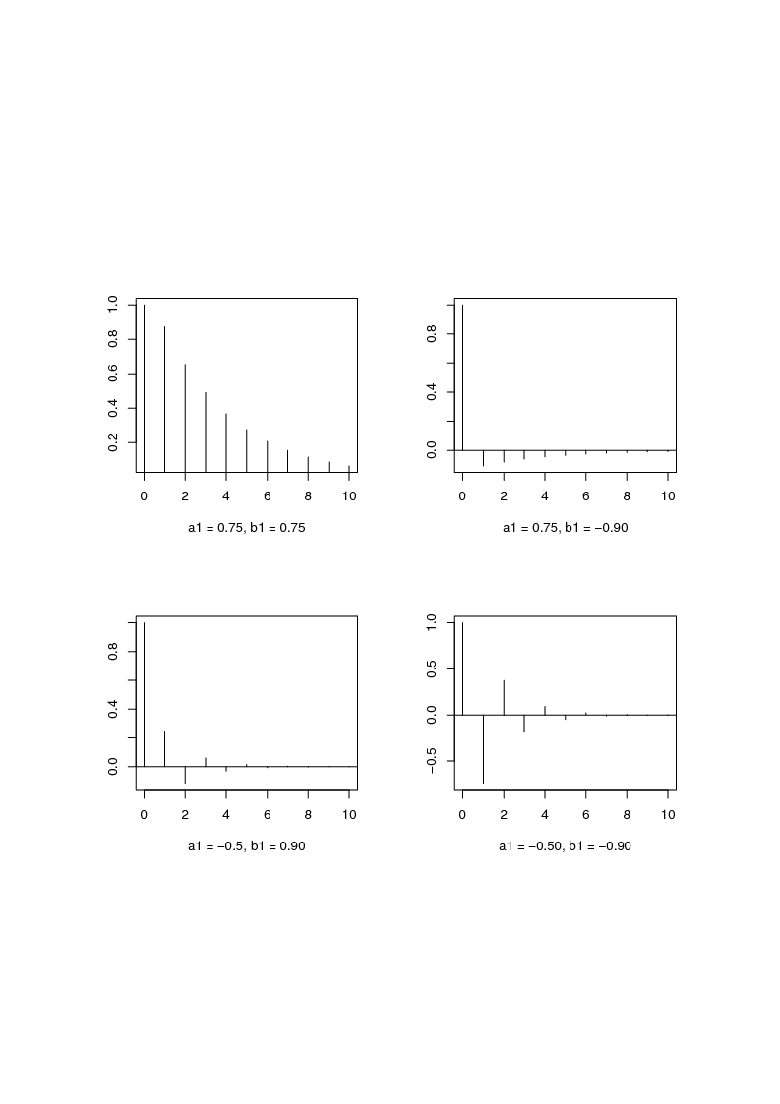**Figure 3.5** Autocorrelograms for ARMA(1,1) Processes

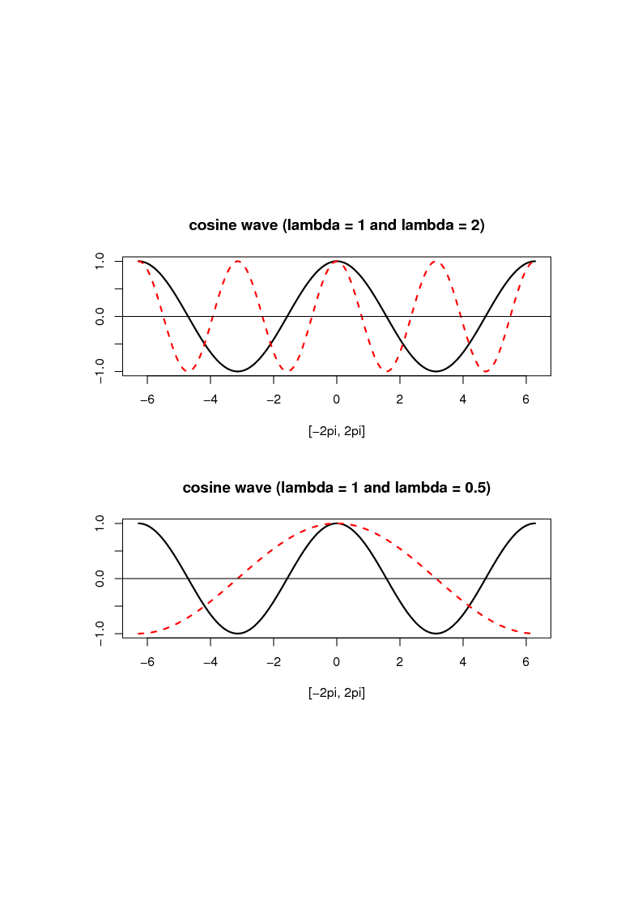

**Figure 4.1** Cosine Cycle with Different Frequencies

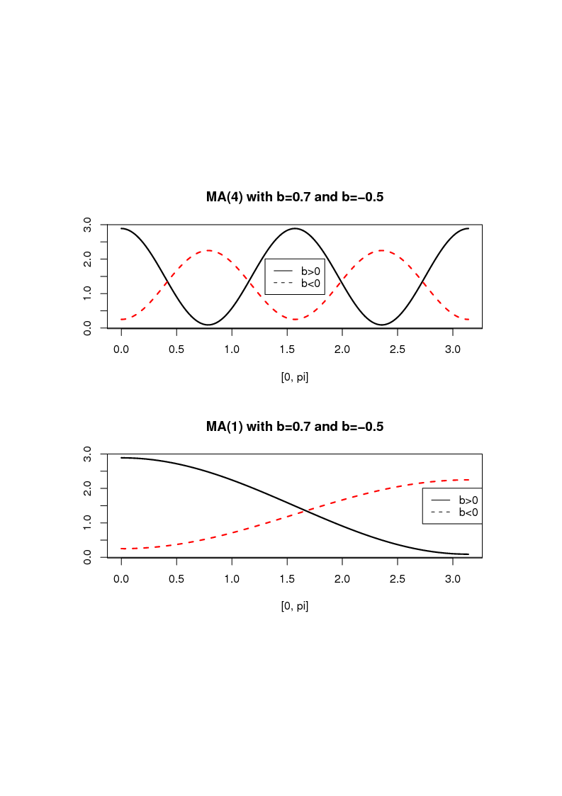

**Figure 4.2** Spectra (2π *f* (λ)) of the MA(*S*) process from Ex. 4.2

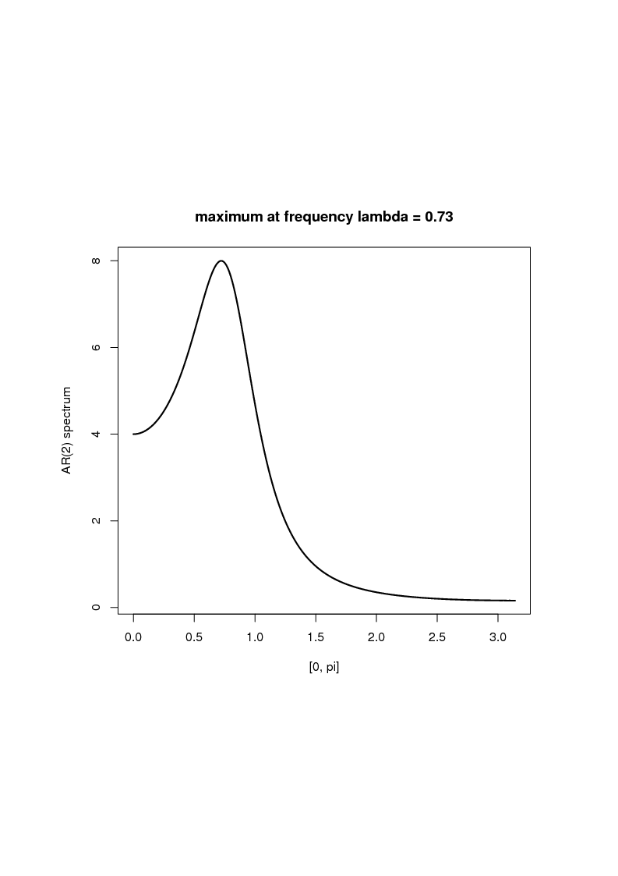

**Figure 4.3** Spectrum (2π *f* (λ)) of Business Cycle with a Period of 8.6 years

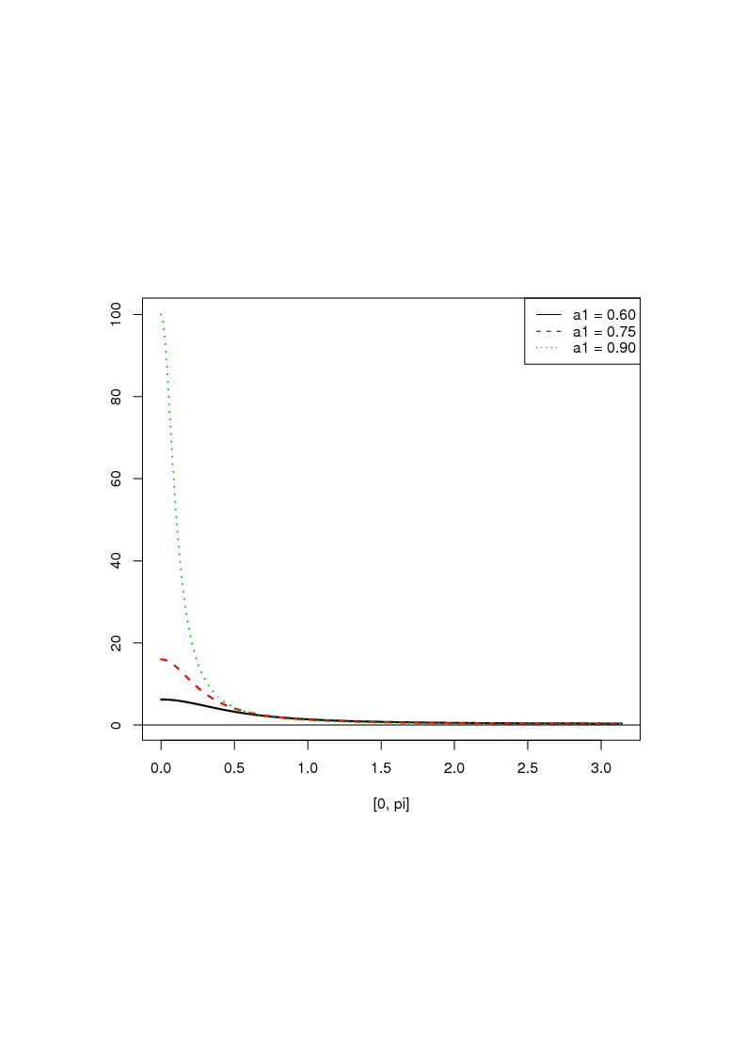

**Figure 4.4** AR(1) Spectra (2π *f* (λ)) with Positive Autocorrelation

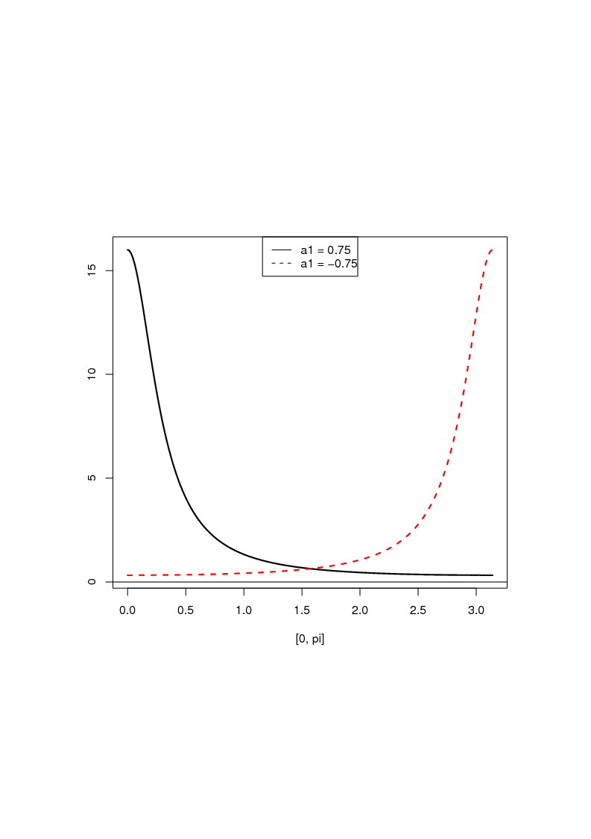

**Figure 4.5** AR(1) Spectra (2π *f* (λ)), cf. Figure 3.2

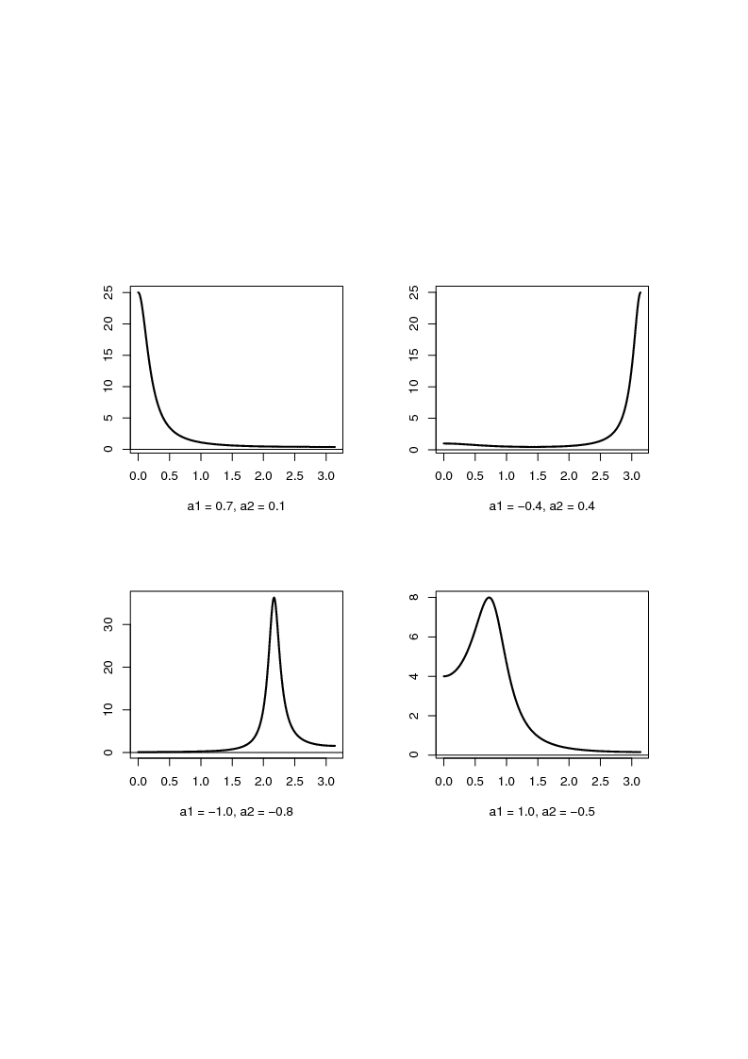

**Figure 4.6** AR(2) Spectra (2π *f* (λ)), cf. Figure 3.4

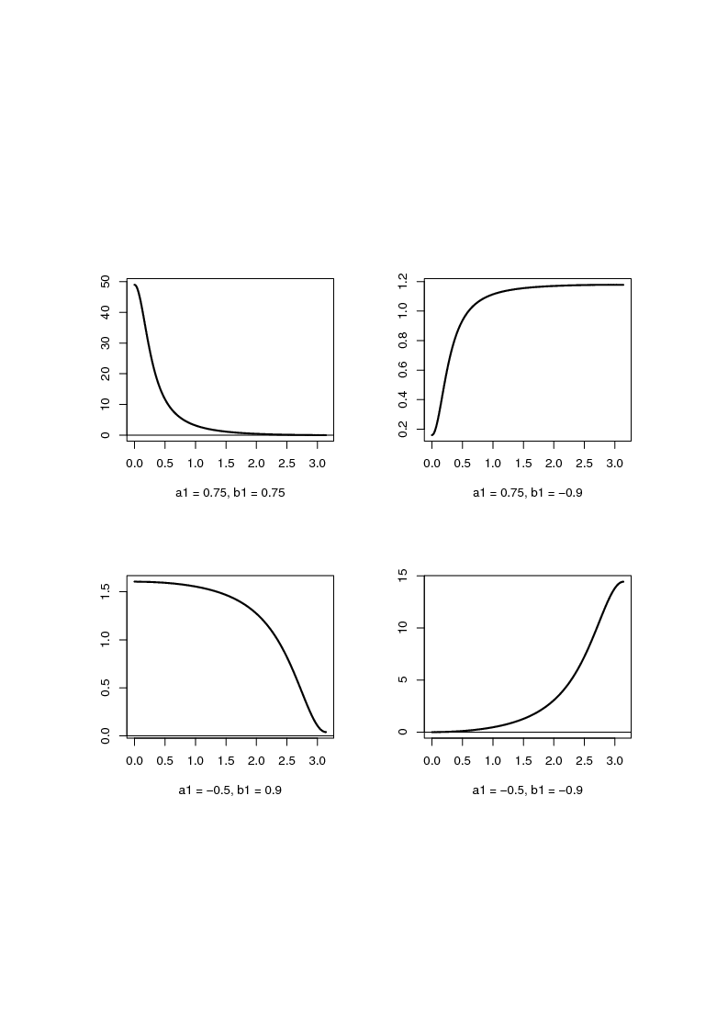

**Figure 4.7** ARMA(1,1) Spectra (2π *f* (λ)), cf. Figure 3.5

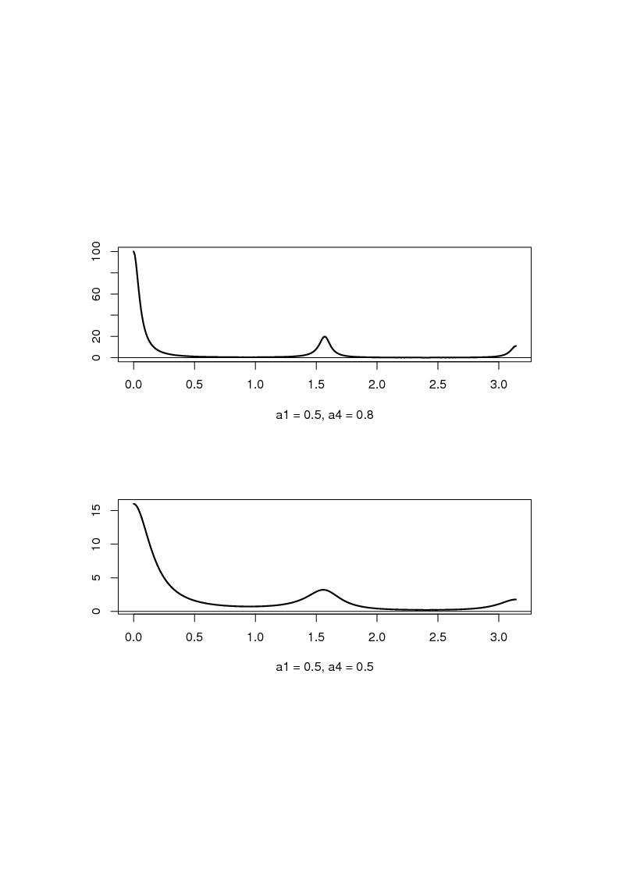

**Figure 4.8** Spectra (2π *f* (λ)) of Multiplicative Seasonal AR Processess (*S* = 4)

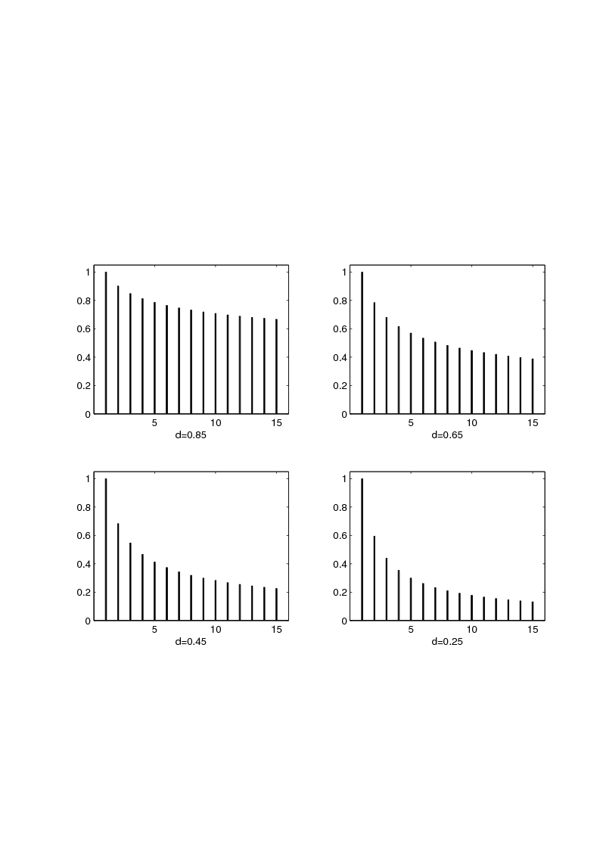

**Figure 5.1** *j**d*-1 for *d* = 0.85, 0.65, 0.45, 0.25

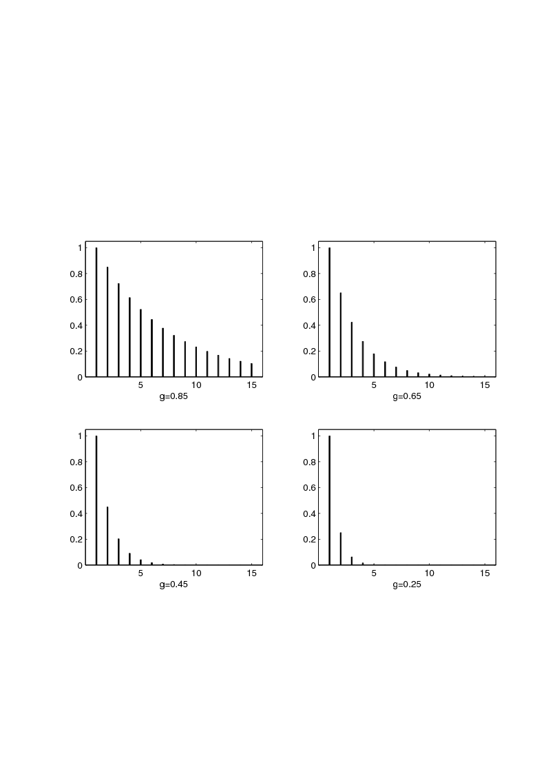

**Figure 5.2** *g**j*-1 for *g* = 0.85, 0.65, 0.45, 0.25

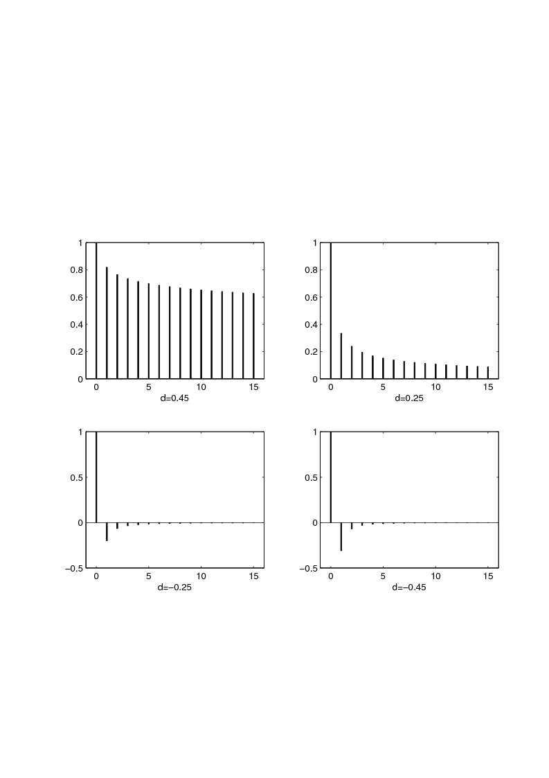

**Figure 5.3** *ρ(h)* from Prop. 5.1 for *d* = 0.45, 0.25, -0.25, -0.45

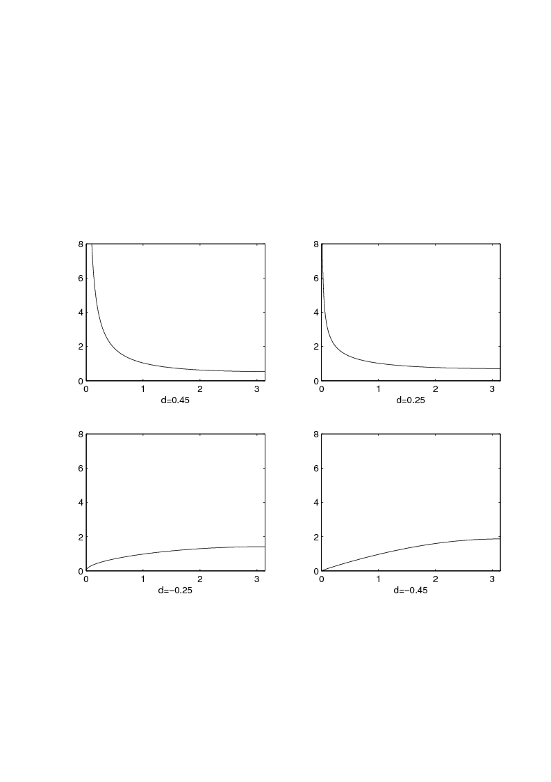

**Figure 5.4** 2π *f* (λ) from Prop. 5.2 for *d* = 0.45, 0.25, -0.25, -0.45

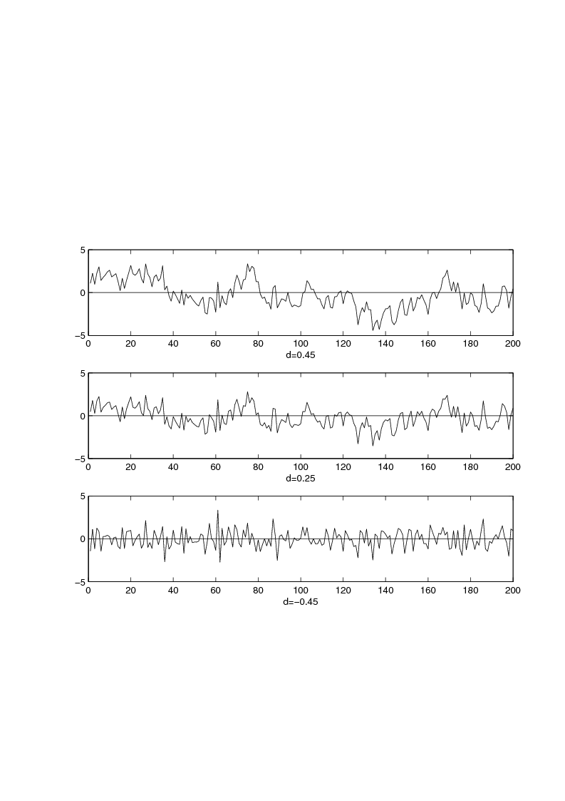

**Figure 5.5** Simulated Fractional Noise for *d* = 0.45, 0.25, -0.45

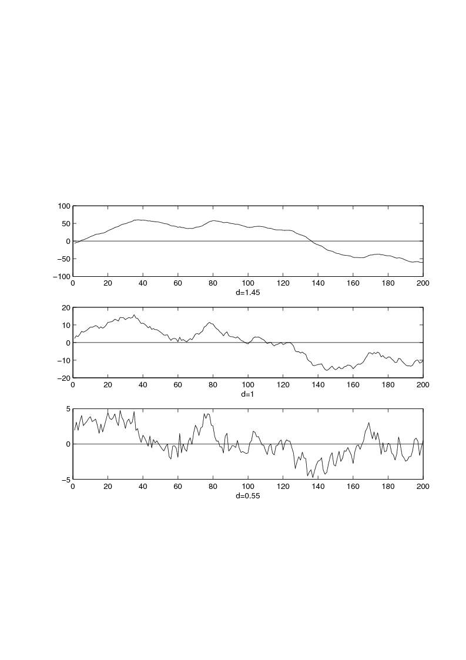

**Figure 5.6** Nonstationary Fractional Noise for *d* = 1.45, 1.0, 0.55

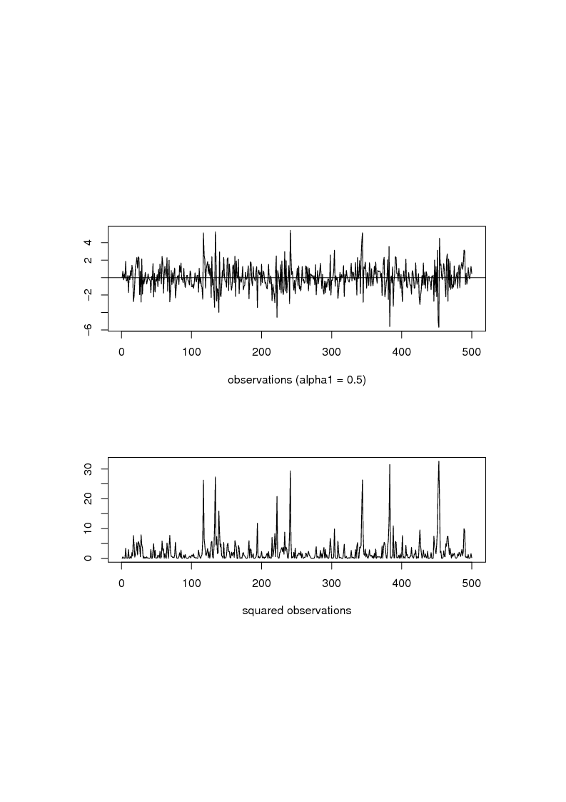

**Figure 6.1** ARCH(1) with α0 = 1 and α1 = 0.5

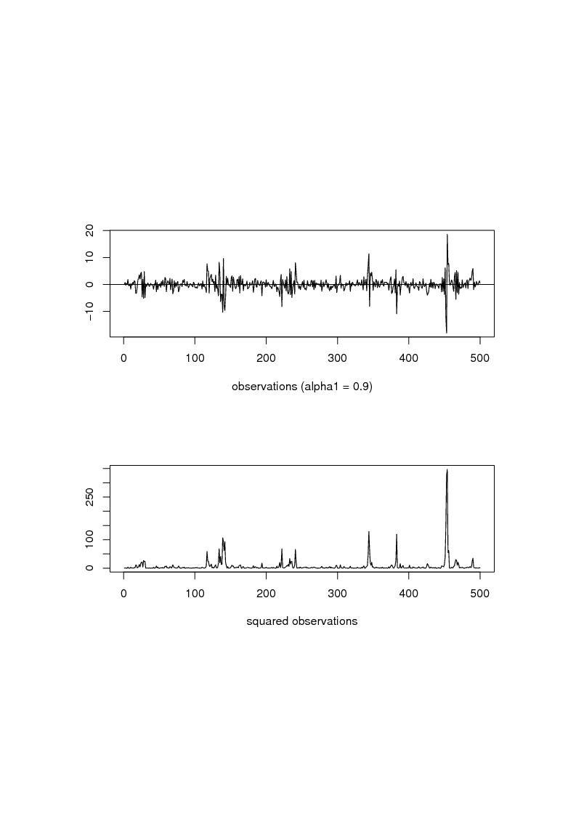

**Figure 6.2** ARCH(1) with α0 = 1 and α1 = 0.9

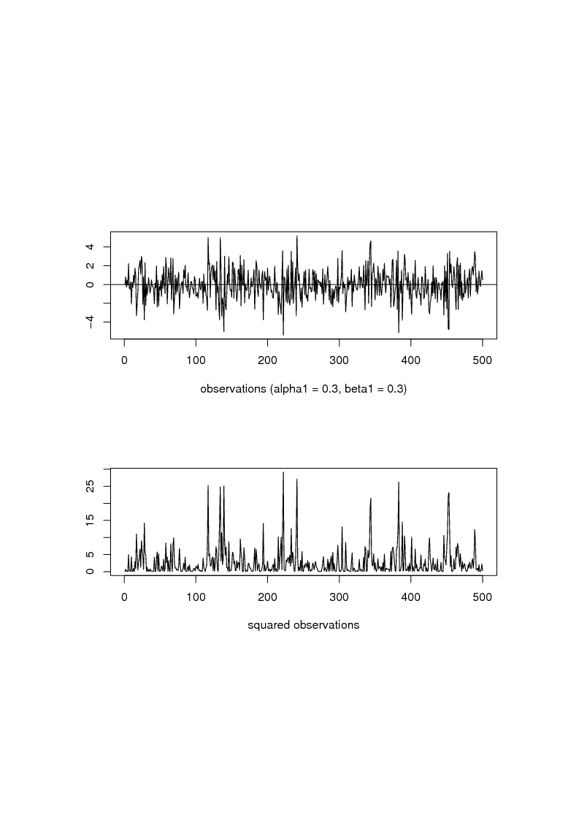

**Figure 6.3** GARCH(1,1) with with α0 = 1 and α1 = 0.3 and β1 = 0.3

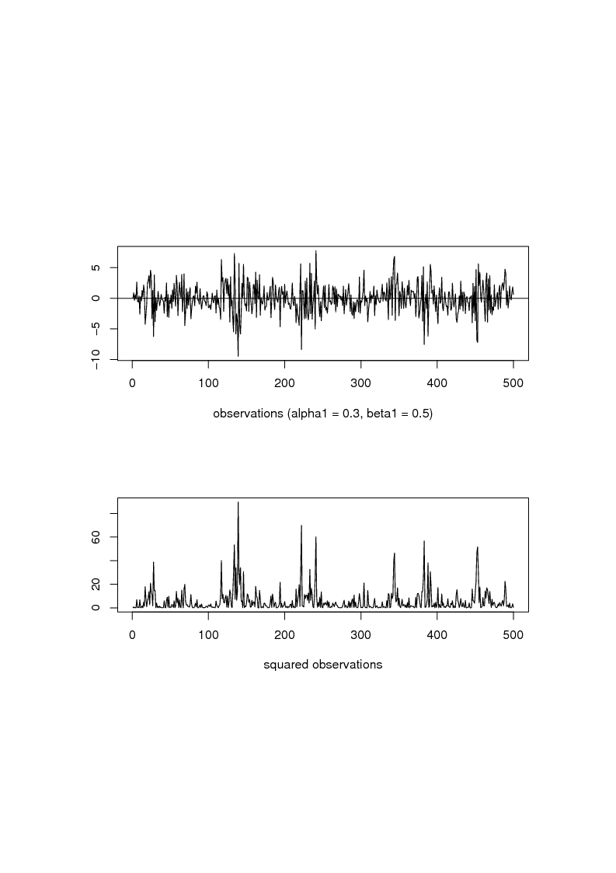

**Figure 6.4** GARCH(1,1) with α0 = 1 and α1 = 0.3 and β1 = 0.5

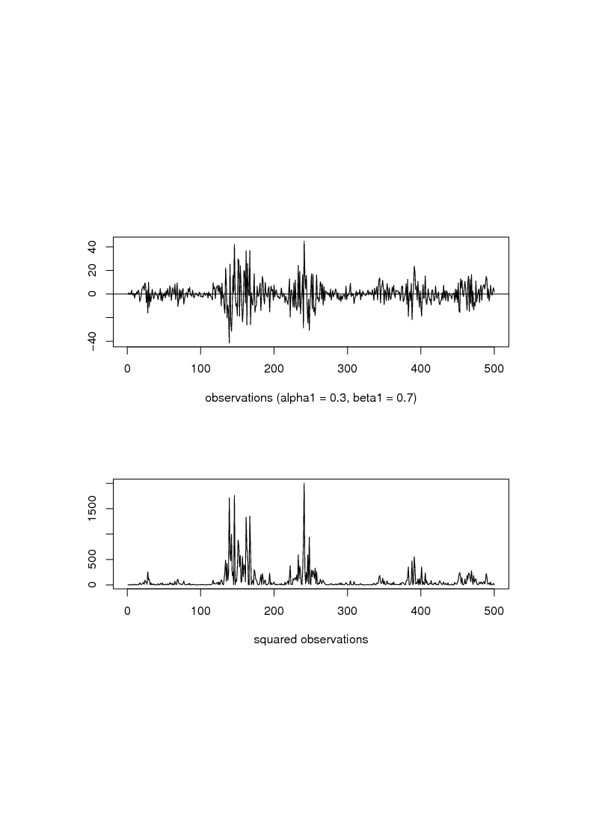

**Figure 6.5** IGARCH(1,1) with α0 = 1 and α1 = 0.3 and β1 = 0.7

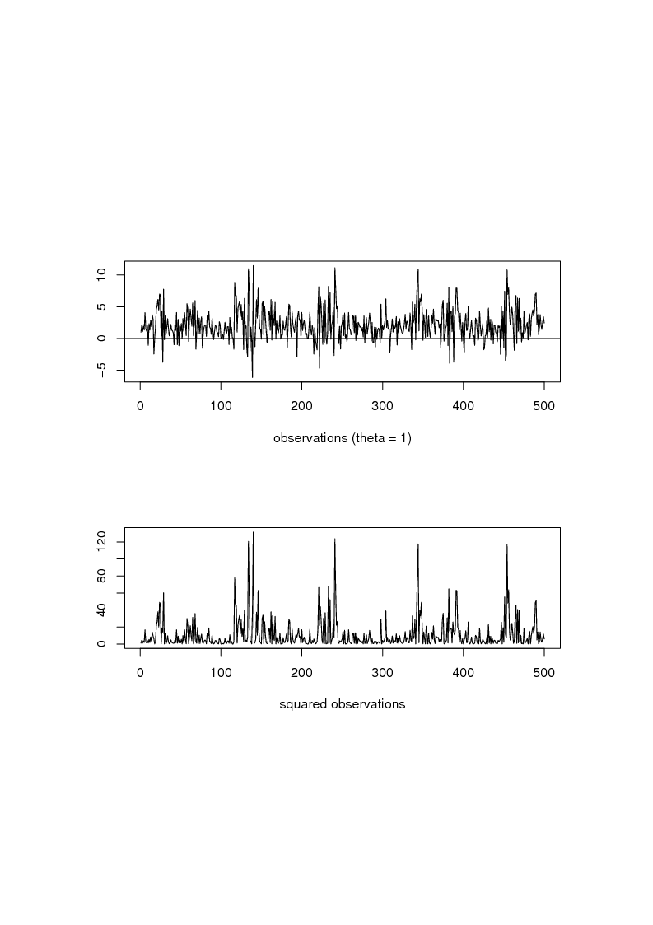

**Figure 6.6** GARCH(1,1)-M from (6.11) with α0 = 1 and α1 = 0.3 and β1 = 0.5

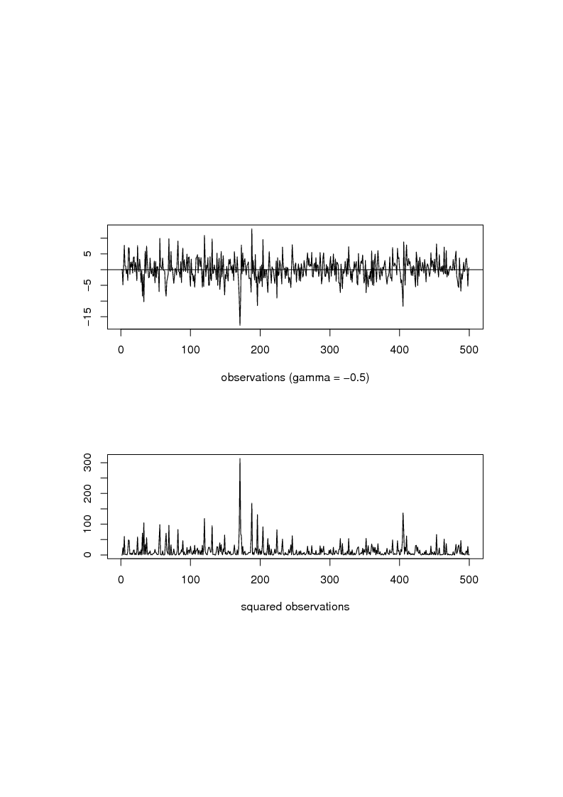

**Figure 6.7** EGARCH(1,1) with ω = 1, α1 = 0.3 and β1 = 0.5 and γ1 = -0.5

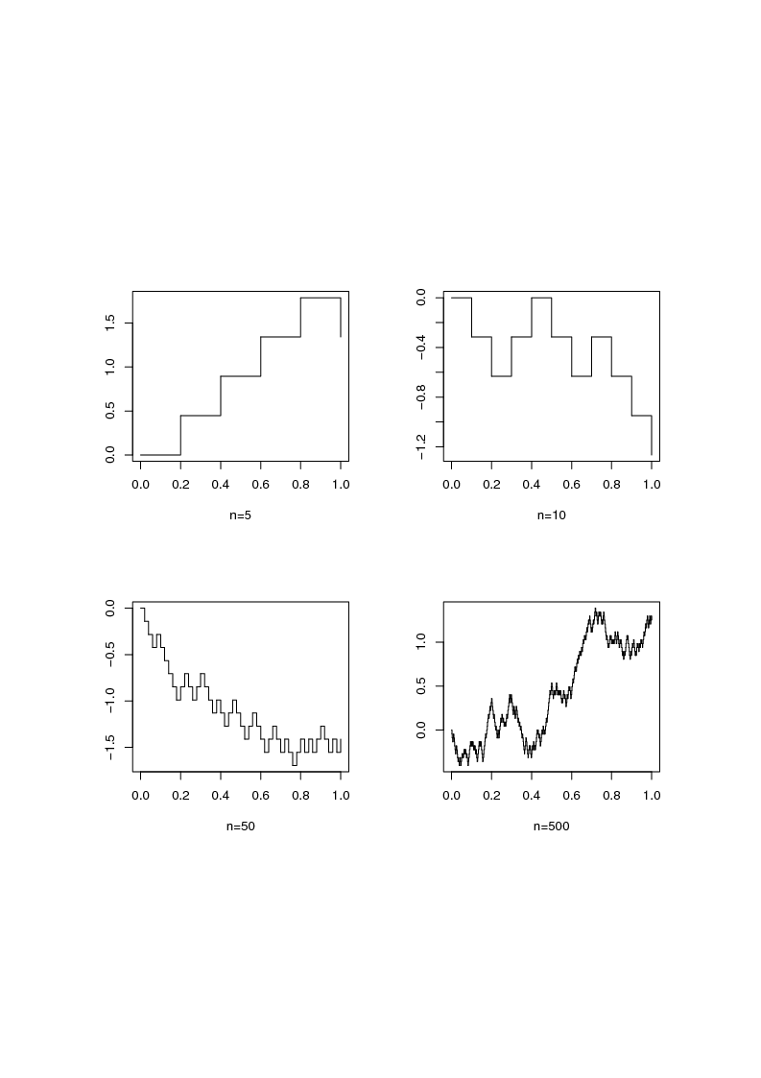

**Figure 7.1** Step Function from (7.1) on the Interval [0,1]

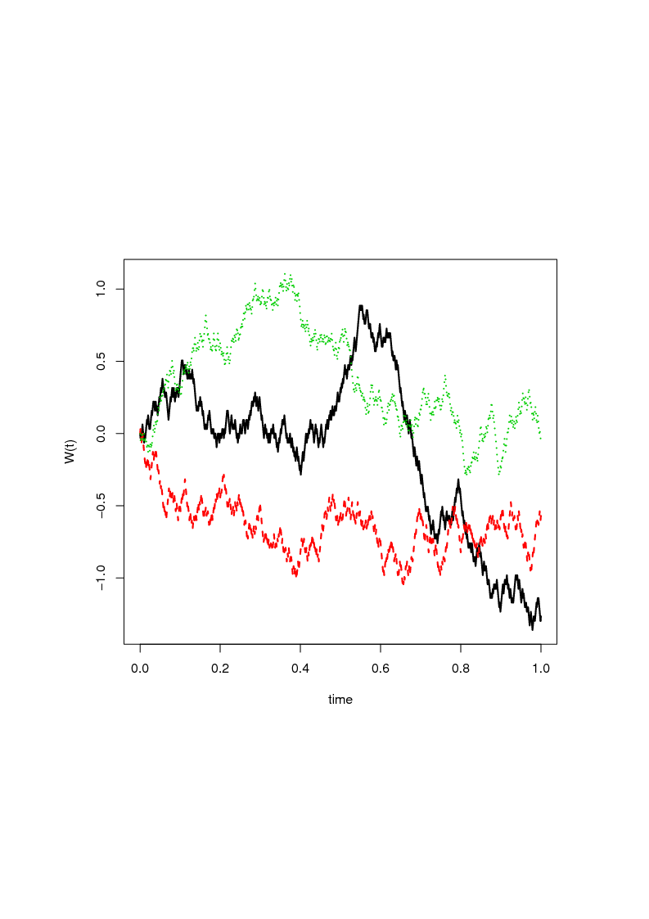

**Figure 7.2** Simulated Paths of the WP on the Interval [0,1]

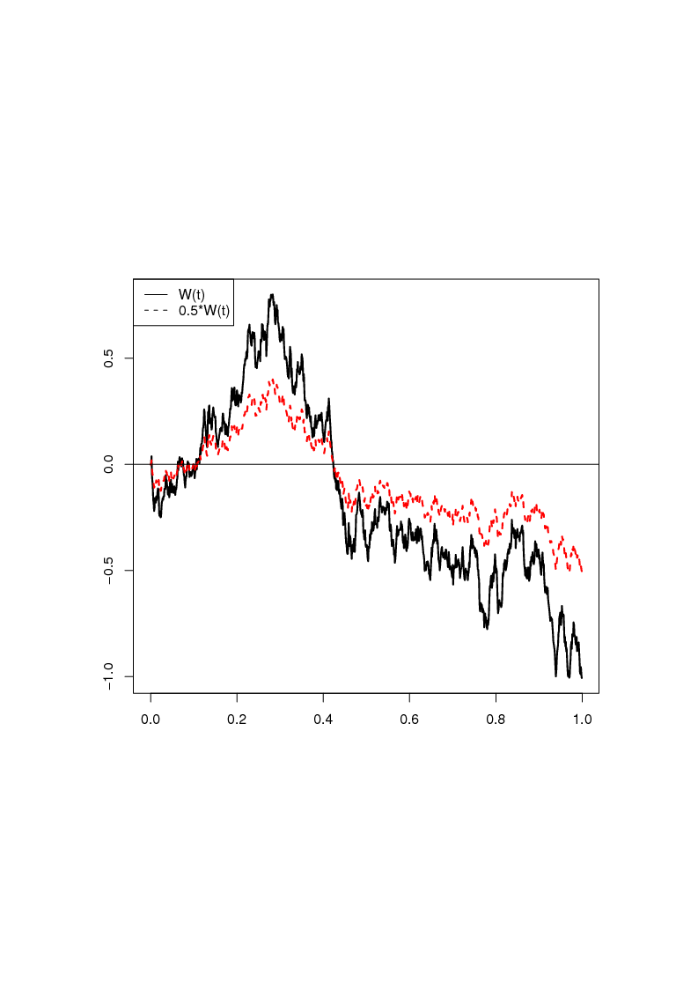

**Figure 7.3** WP and Brownian Motion with σ = 0.5

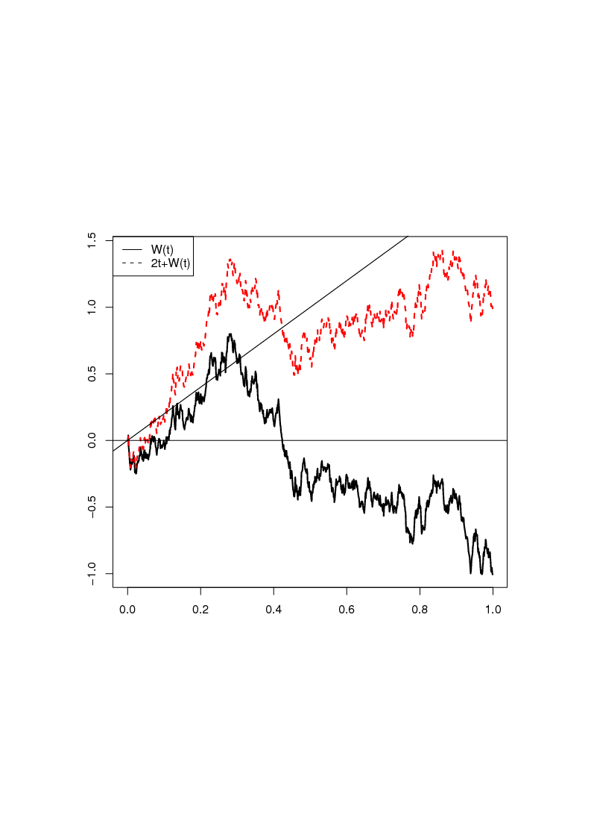

**Figure 7.4** WP and Brownian Motion with Drift, where σ = 1

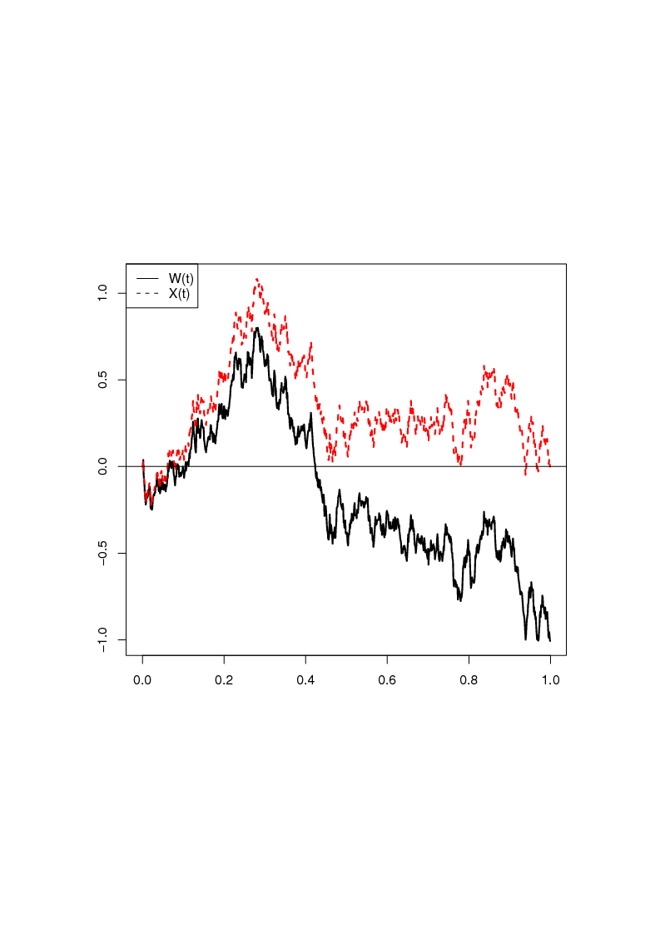

**Figure 7.5** WP and Brownian Bridge (σ = 1)

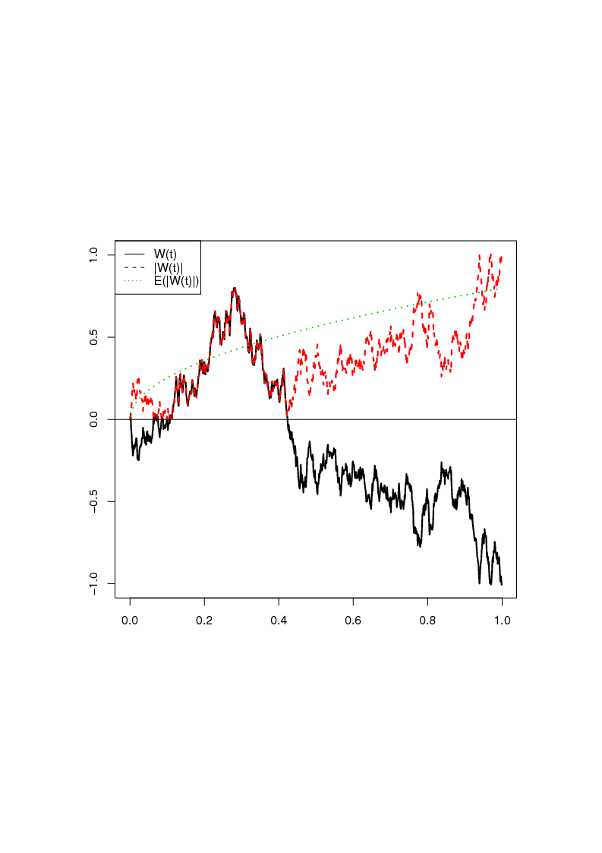

**Figure 7.6** WP and reflected WP along with Expectation

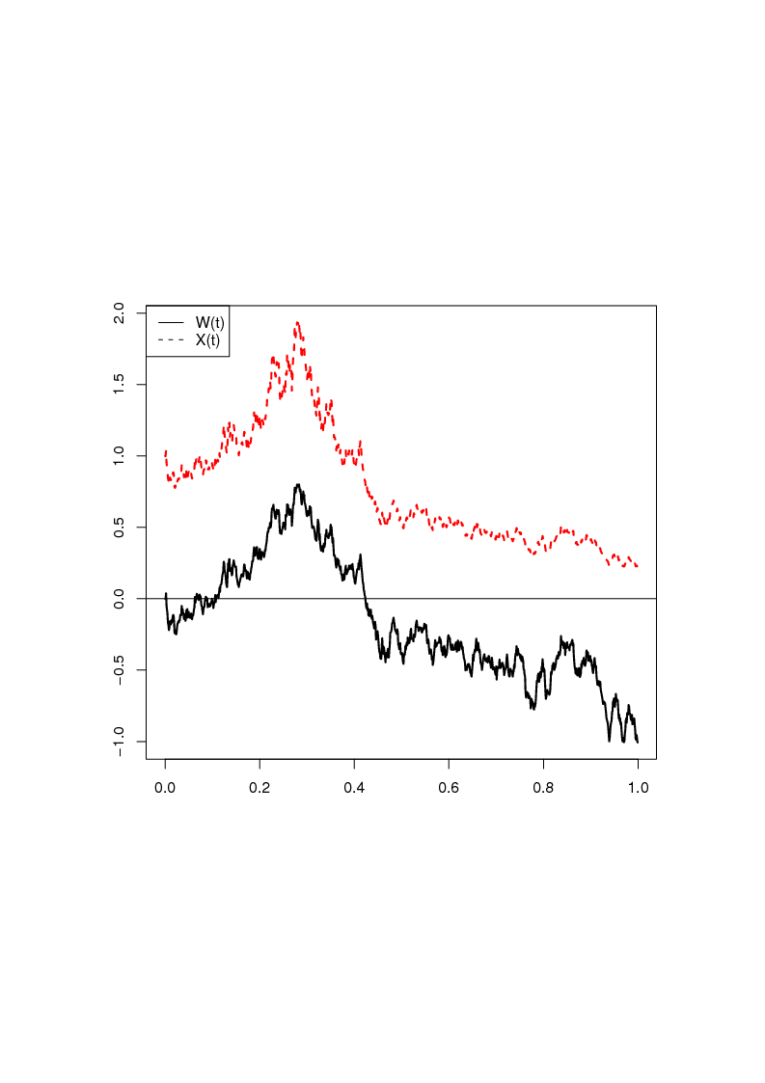

**Figure 7.7** WP and Geometric Brownian Motion with μ = -0.5 and σ = 1

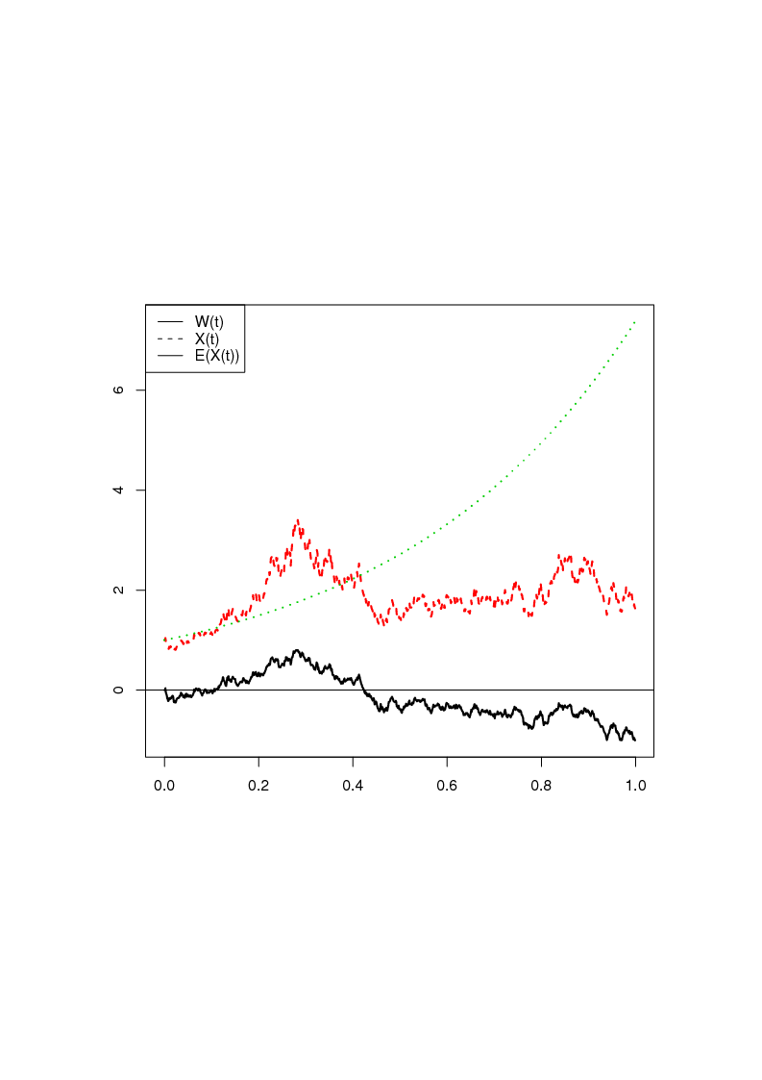

**Figure 7.8** Geometric Brownian Motion with μ = 1.5 and σ = 1 along with Expectation

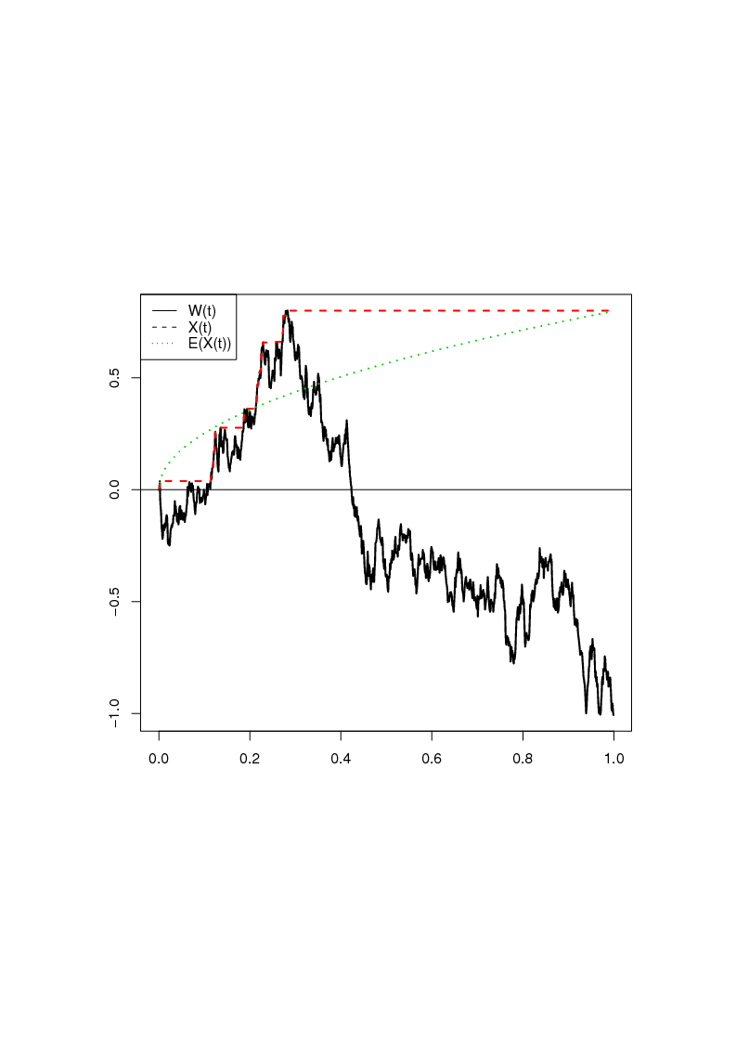

**Figure 7.9** WP and Maximum Process along with Expectation

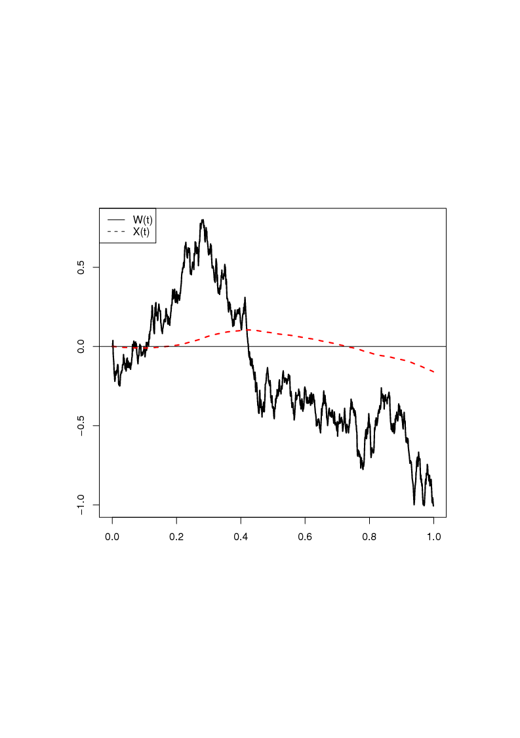

**Figure 7.10** WP and integrated WP

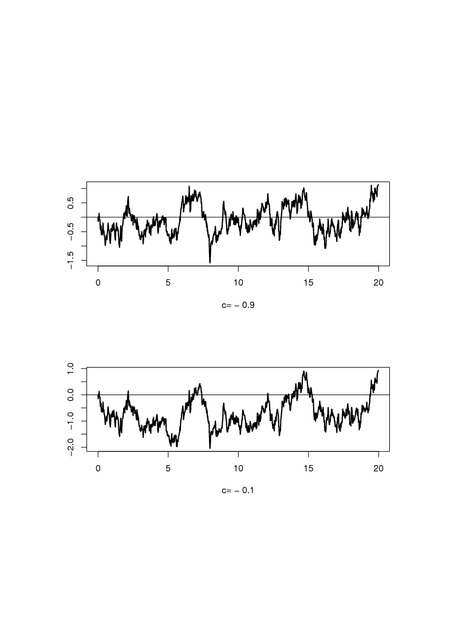

**Figure 9.1** Standard Ornstein-Uhlenbeck Processes

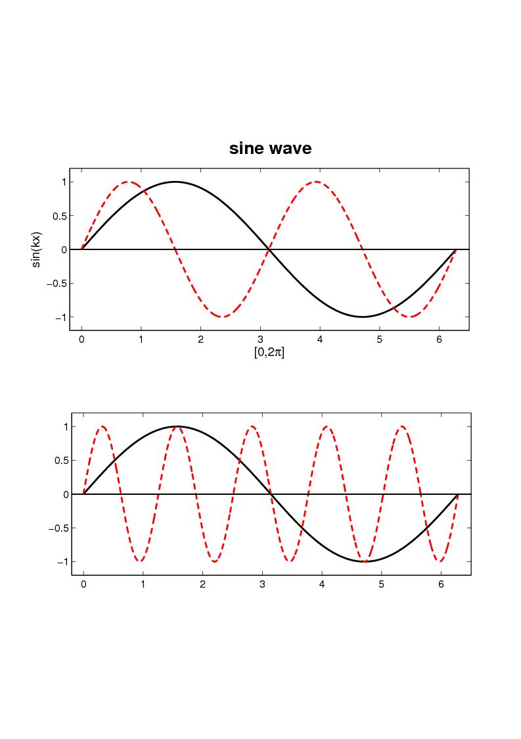**Figure 10.1** Sine Cycles of Different Frequencies (Example 10.5)

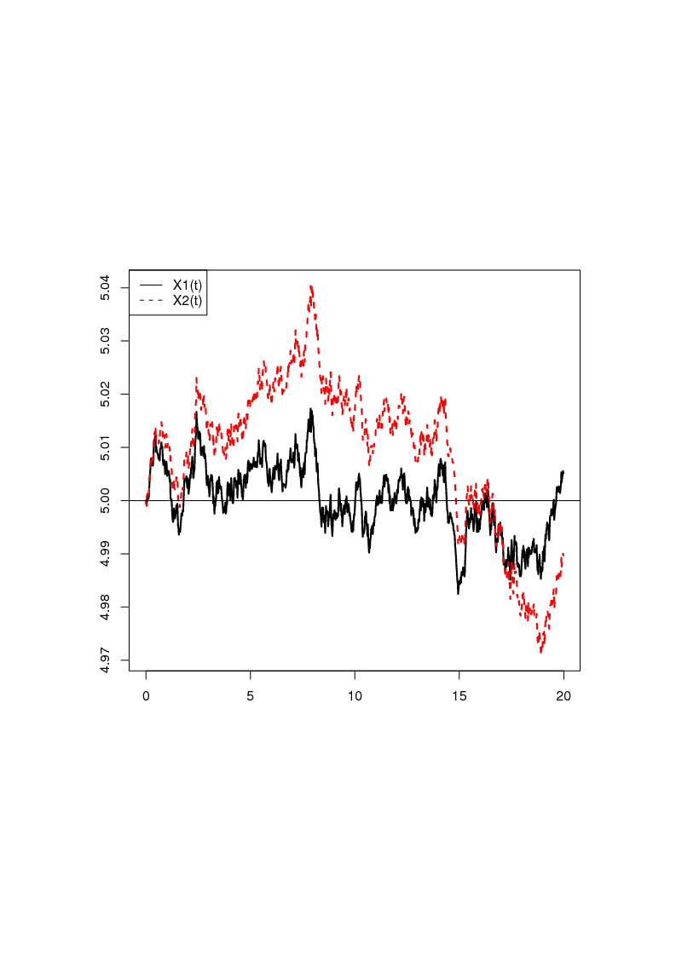

**Figure 13.1** OUP for *c*1 = -0.9 (*X*1) and *c*1 = -0.1 (*X*2) (*X* (0) = μ = 5, σ2 = 0.01)

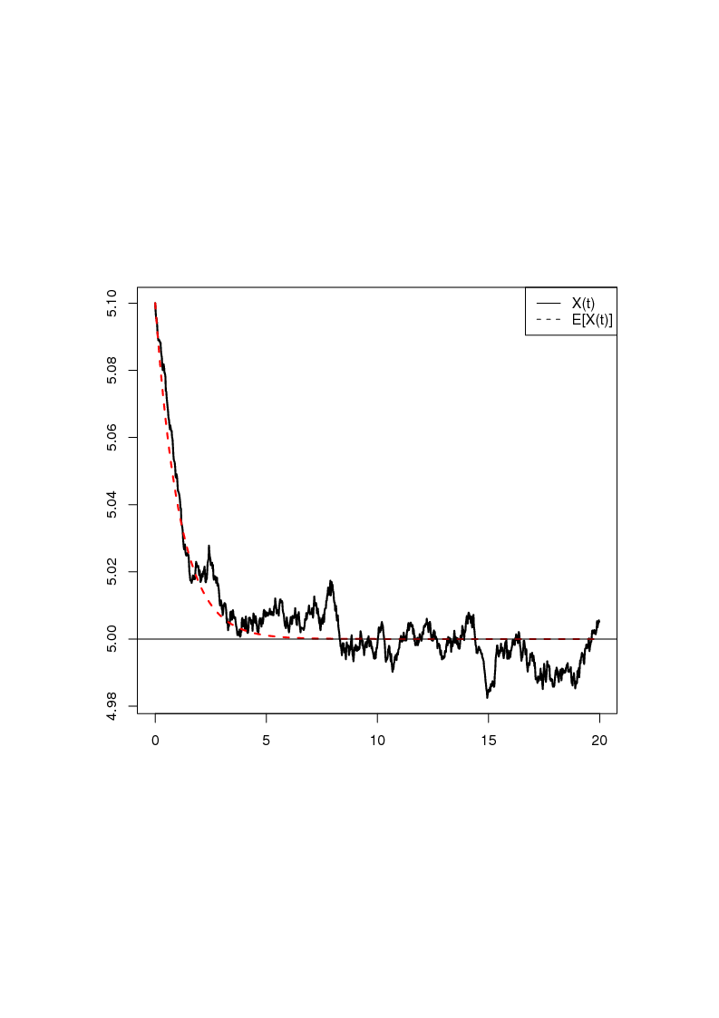

**Figure 13.2** OUP for *c*1 = -0.9 and Starting Value *X*(0) = 5.1 including Expected Value Function (μ = 5, σ2 = 0.01)

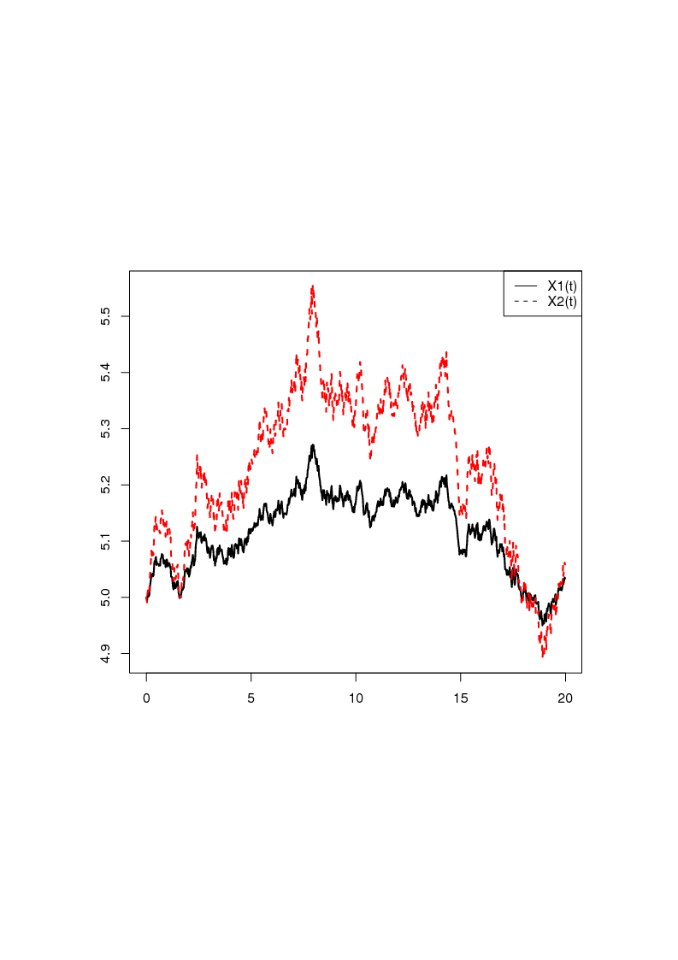

**Figure 13.3** Dothan for σ1 = 0.01 (*X*1) and σ1 = 0.02 (*X*2) (*X* (0) = μ = 5)

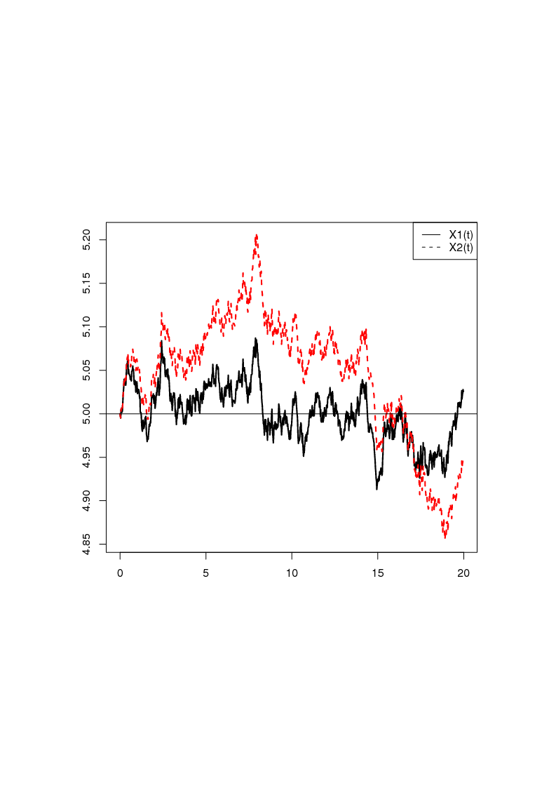

**Figure 13.4** Brennan-Schwartz for *c*1 = -0.9 (*X*1) and *c*1 = -0.1 (*X*2) (*X* (0) = μ = 5, σ1 = 0.01)

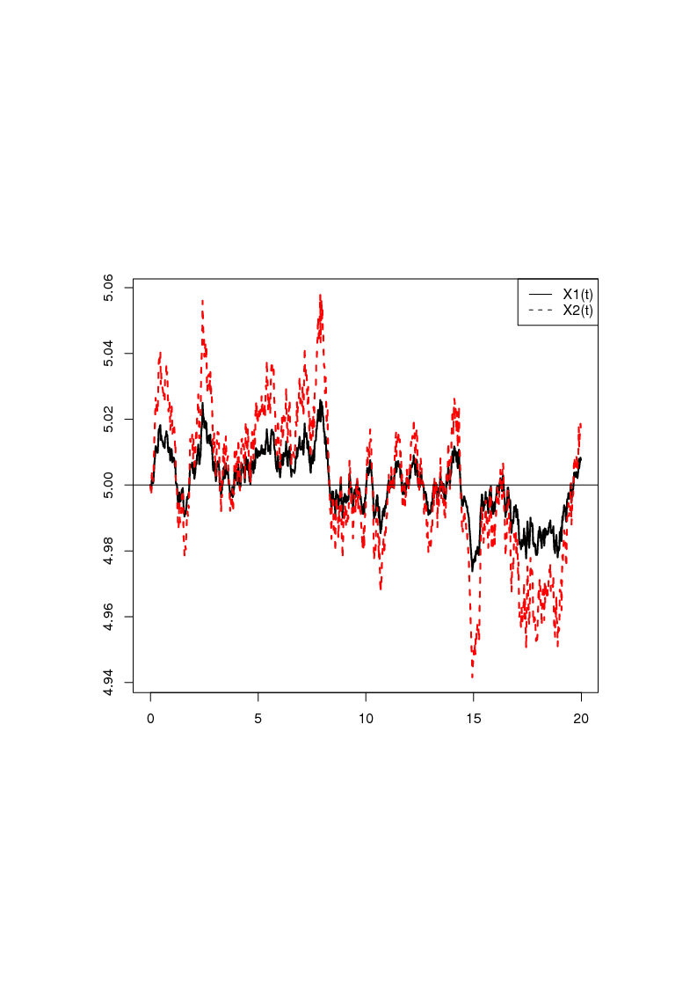

**Figure 13.5** CKLS with γ = 0.25 (*X*1) and γ = 0.75 (*X*2) for *c*1 = -0.9 (*X* (0) = μ = 5, σ1 = 0.01)

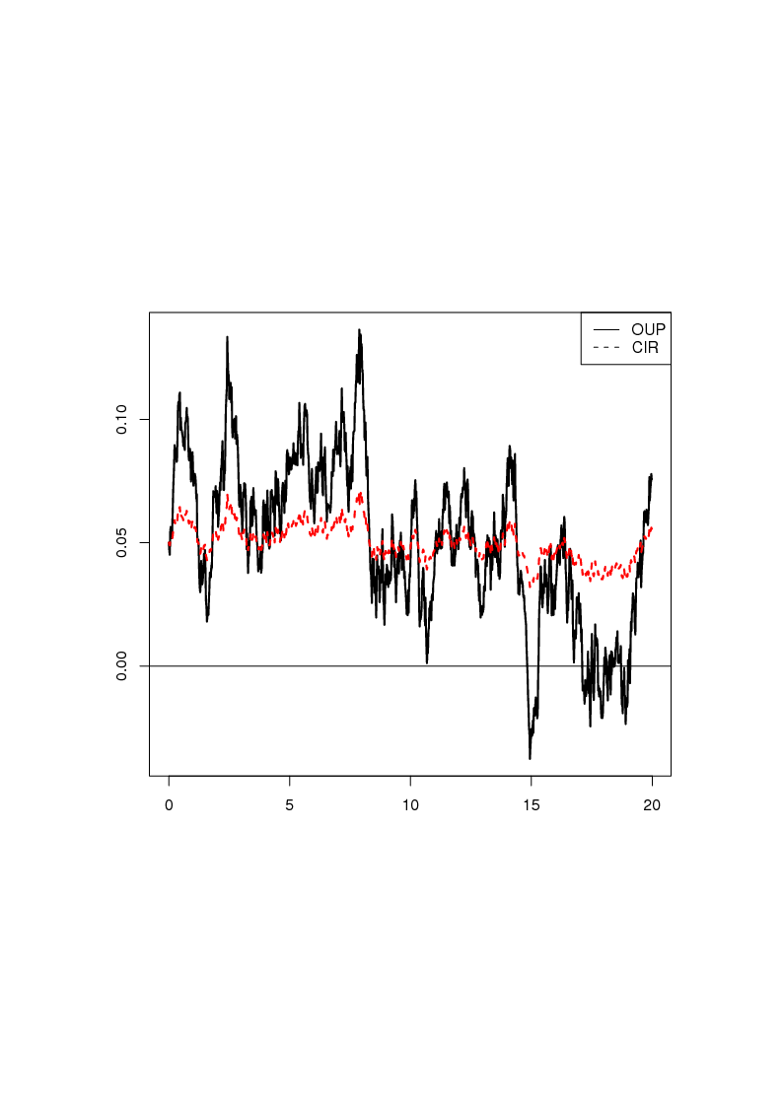

**Figure 13.6** OUP and CIR for *c*1 = -0.9 (*X* (0) = μ = 5, σ = σ2 = 0.01)

C:\Users\s6796080\Documents\figures\Int_Reg\lin_trend_tomi.eps

**Figure 15.1** Linear Time Trend